**Unit 5 Project Overview:**

**Mary Katrantzou Website**

**Step 1: Define Audience / Tone**

* Who will visit your site? Potential employers? New clients or customers?

People who are driven to fashion trends associated with London Fashion Week.

* What can make you and/or your product stand out against your competitors?

Strong visual collaterals.

* What colors represent you or your product?

Black and white for website since the product is already very colorful.

* What images illustrate your message?

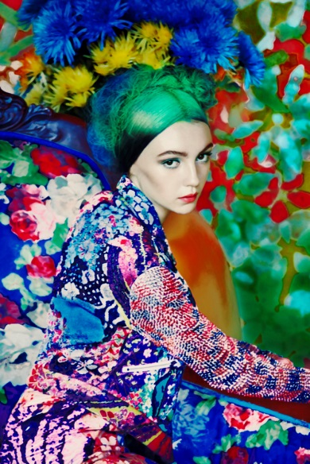

The campaign image from the original Mary Katrantzou collection 2011.

**Step 2: Define Site Structure**

* What are the three-to-five pages titled?

Shop, Collections, Projects, Mary’s World and About

* What will be the purpose for each?

Shop: e-commerce shop

Collections: show the products by collections

Projects: featuring special collaborate projects

Mary’s World: Press or features in the social media

About: about the fashion designer Mary Katrantzou and the company

**Homepage**

*Intro to the brand Mary Katrantzou*

Contains:

* Title
* Navigation
* Logo
* Sneak peak of the current collection

**Shop**

*e-commerce page*

Contains:

* Title
* Navigation
* Images of the products
  + Shop the look
  + Shop accessories
  + Shop shoes
  + Shop the show
  + Shop Dresses

**Collections**

*Show our seasonal fashion show*

* Title
* Navigation
* Image of the products
  + Runway looks
  + Video
  + Backstage video
  + Backstage pass

**Mary’s World**

* Title
* Navigation
* Up-to-date social media post
* Photos featured in press
* Celebrities

**About**

*Biography*

* Title
* Navigation
* About the designer
* Career
* contact